ARTIFICAL INTELLIGENCE
ASSESSMENT TOOLS-1

REG.no. 192512417

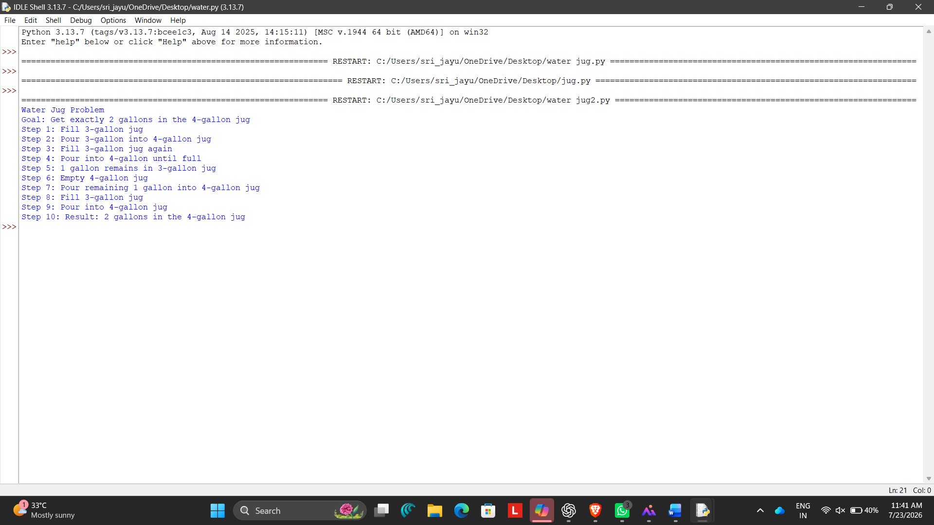
1.Water jug output

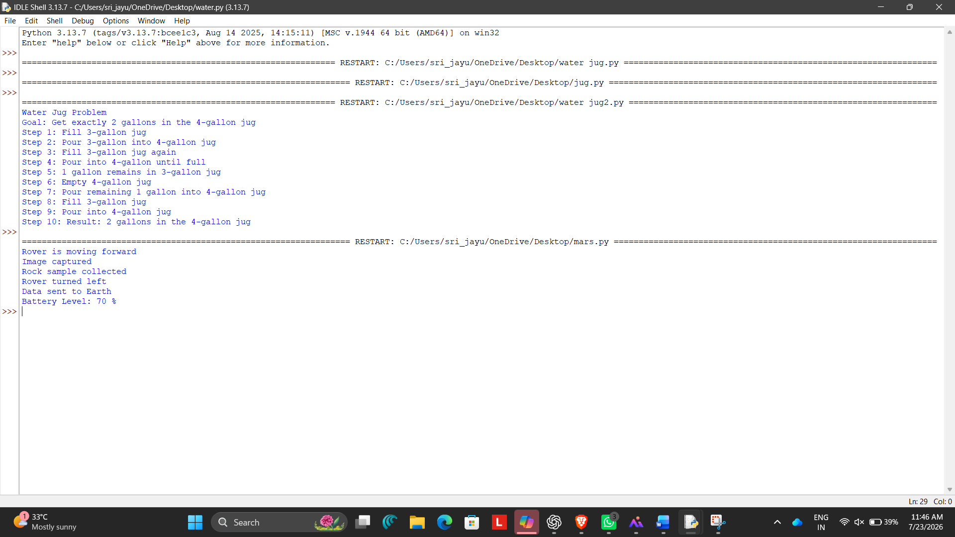
2. Marsrover

3. 8 QUEEN PROBLEM
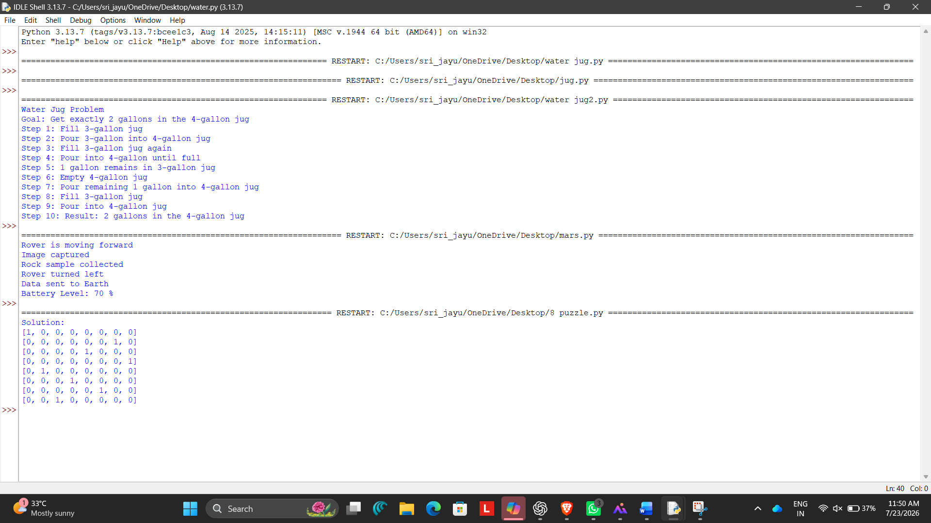
4. OLA CAB
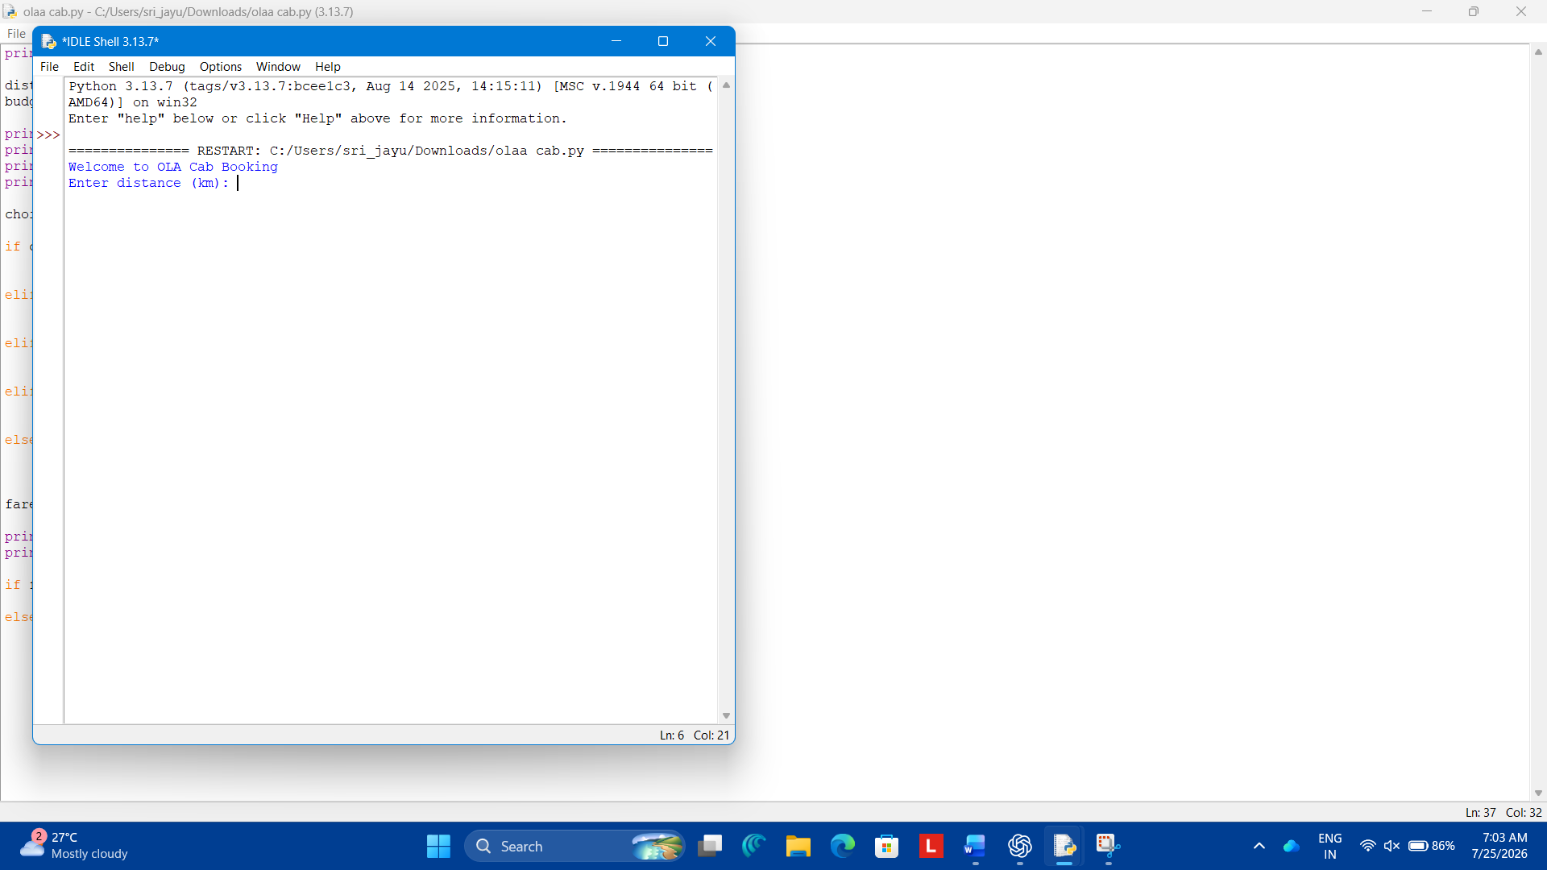

5. UNIFORM COST SEARCH
